

**Statement of Work V1**

**AIDI 1002-02 AI Algorithms 1**

**Professor – Marcos Bittencourt**

**Email: -** [**marcos.bittencourt@dcfaculty.mycampus.ca**](mailto:marcos.bittencourt@dcfaculty.mycampus.ca)

**Submitted by:**

**Biraj Prajapati (100766706)**

1. Rational Statement: Loan Prediction Problem
2. Business Problem in Brief:

Find out the person is eligible to acquire loan based on their qualifications, employment, earning, dependent, their dependent’s income, credit history, their loan amount, and loan term. Create a machine learning model to generate loan approval from person’s information.

1. Data Source: <https://www.kaggle.com/altruistdelhite04/loan-prediction-problem>

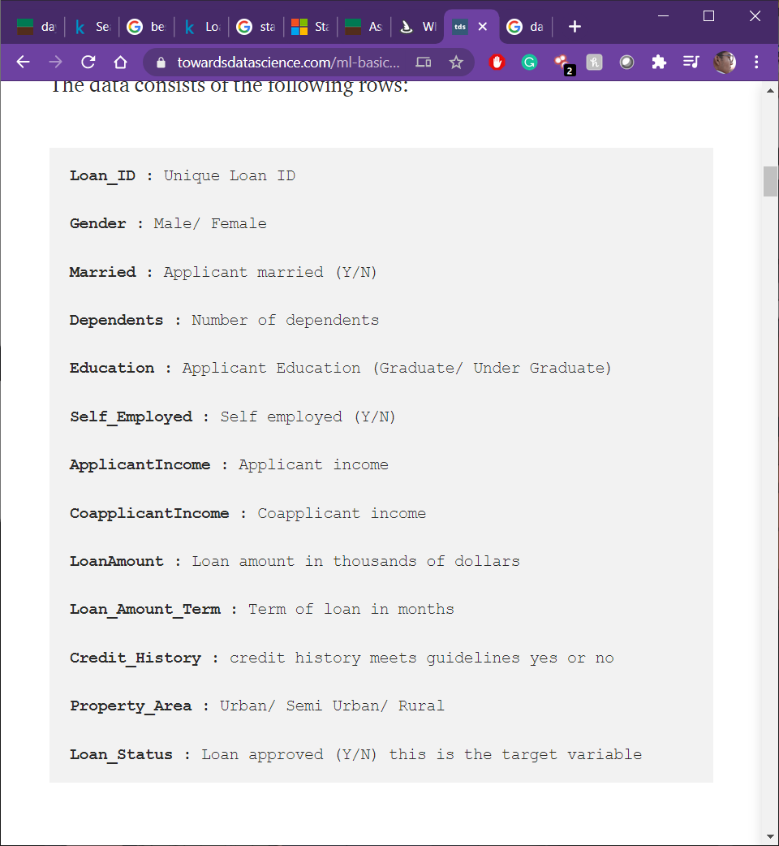

Image 1 (Source: towardsdatascience)

1. Data Requirement:

Gender, married, dependents, education, self-employed, applicant income, co-applicant income, loan amount, loan term, credit history, property area and loan status.

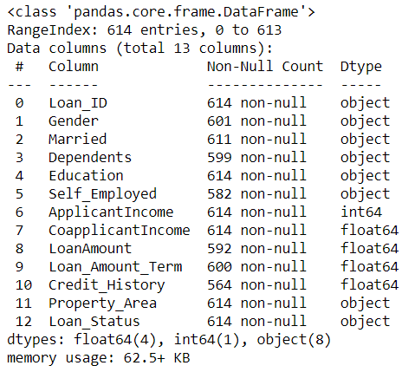

1. Data Assumption:

* Decision tree will have high accuracy than random forest, and logistic regression
* Loan status is extremely reliant on credit history.
* Linear relationship between columns.

1. Data Limitations and Constraints:

Dataset only got 613 entries in train dataset and 366 entries in test dataset. Dataset got some missing values in some columns, which need to be cleaned.

1. Test Process:

Data Cleaning 🡪 EDA 🡪 Feature Engineering 🡪 Preprocessing 🡪 Modeling 🡪 Model testing

References:

Image 1 source: <https://towardsdatascience.com/ml-basics-loan-prediction-d695ba7f31f6>

Dataset source: <https://www.kaggle.com/altruistdelhite04/loan-prediction-problem>